 

A Minor Project Report

On

HOME CARE SERVICE

Submitted in partial fulfillment of requirements for the award of the Degree of

## BACHELOR OF ENGINEERING

in

## COMPUTER SCIENCE AND ENGINEERING

Under the guidance of

## Mrs. S. SANTHIYA M.E.,

**Assistant Professor - CSE**

Submitted By

## ABEESH R (927621BCS003) CHANDHRAKIRAN S V (927621BCS016) JAYAPRASATH K (927621BCS043) KALEESWARAN T (927621BCS049)

**DEPARTMENT OF COMPUTER SCIENCE AND ENGINEERING**

**M. KUMARASAMY COLLEGE OF ENGINEERING**

(Autonomous)

## KARUR – 639 113

**April 2023**

 

# M. KUMARASAMY COLLEGE OF ENGINEERING

**(Autonomous Institution affiliated to Anna University, Chennai)**

# KARUR–639113

**BONAFIDE CERTIFICATE**

Certified that this minor project report **“HOME CARE SERVICE”** is the bonafide work of **“ABEESH R (927621BCS003), CHANDHRAKIRAN S V (927621BCS016), JAYAPRASATH K (927621BCS043),KALEESWARAN T**

**(927621BCS049)”** who carried out the project work during the academic year 2023- 2024 under my supervision.

Signature Signature

**Mrs. S. SANTHIYA M.E., Dr. M. MURUGESAN M.E., Ph.D.,**

## SUPERVISOR, HEAD OF THE DEPARTMENT,

Department of Computer Science and Engineering,

M.Kumarasamy College of Engineering, Thalavapalayam, Karur - 639 113.

Department of Computer Science and Engineering,

M.Kumarasamy College of Engineering, Thalavapalayam, Karur - 639 113.

 

## DEPARTMENT OF COMPUTERSCIENCE AND ENGINEERING VISION OF THE INSTITUTION

* To emerge as a leader among the top institutions in the field of technical education.

## MISSION OF THE INSTITUTION

 Produce smart technocrats with empirical knowledge who can surmount the global challenges.

Create a diverse, fully-engaged, learner-centric campus environment to provide quality education to the students.

 Maintain mutually beneficial partner ships with our alumni, industry, and professional associations.

## VISION OF THE DEPARTMENT

*To achieve education and research excellence in Computer Science and Engineering.

## MISSION OF THE DEPARTMENT

To excel in academic through effective teaching-learning techniques. To promote research in the area of computer science and engineering with a focus on innovation

To transform students into technically competent professionals with societal and ethical responsibilities.

## PROGRAM EDUCATIONAL OBJECTIVES(PEOs)

**PEO1:** Graduates will have successful career in software industries and R&D divisions through continuous learning.

**PEO2:** Graduates will provide effective solutions for real world problems in the key domain of computer science and engineering and engage in lifelong learning.

**PEO3:** Graduates will excel in their profession by being ethically and socially responsible.

 

## PROGRAM OUTCOMES(POs)

**Engineering students will be able to:**

1. **Engineering knowledge:** Apply the knowledge of mathematics, science, engineering fundamentals, and an engineering specialization to the solution of complex engineering problems
2. **Problem analysis:** Identity, formulate, review research literature, and analyze complex engineering problem searching substantiated conclusions using first principles of mathematic, natural sciences, and engineering sciences.
3. **Design/development of solutions:** Design solutions for complex engineering problems and design system components or processes that meet the specified needs with appropriate consideration for the public health and safety, and the cultural, societal, and environmental considerations.
4. **Conduct investigations of complex problems:** Use research-based knowledge and research methods including design of experiments, analysis and interpretation of data, and synthesis of the information to provide valid conclusions.
5. **Modern tool usage:** Create, select, and apply appropriate techniques, resources, and modern engineering and IT tools including prediction and modeling to complex engineering activities with an understanding of the limitations.
6. **The engineer and society:** Apply reasoning informed by the contextual knowledge to assess societal, health, safety, legal and cultural issues and the consequent responsibilities relevant to the professional engineering practice.
7. **Environment and sustainability:** Understand the impact of the professional engineering solutions in societal and environmental contexts, and demonstrate the knowledge of, and need for sustainable development.
8. **Ethics:** Apply ethical principles and commit to professional ethics and responsibilities and norms of the engineering practice.
9. **Individual and team work:** Function effectively as an individual, and as a member or leader in diverse teams, and in multidisciplinary settings.
10. **Communication:** Communicate effectively on complex engineering activities with the engineering community and with society at large, such as, being able to comprehend and write effective reports and design documentation, make effective presentations, and give and receive clear instructions.
11. **Project management and finance:** Demonstrate knowledge and understanding of the engineering and management principles and apply these to one’s own work, as a member and leader in team, to manage projects and in multidisciplinary environments.
12. **Life-long learning:** Recognize the need for, and have the preparation and ability to engage in independent and life-long learning in the broadest context of technological change.

**PROGRAM SPECIFIC OUTCOMES(PSOs)**

**PSO1: Professional Skills:** Ability to apply the knowledge of computing techniques to design and develop computerized solutions for the problems.

**PSO2: Successful career:** Ability to utilize the computing skills and ethical values in creating a successful career.

# ABSTRACT

In this home care service system, we mainly focuses on household works such as electrical, plumbing, taking care of senior citizens, etc. We are intended to create a website which allows the people to solve their problems on their homes in easy manner. In this website, we include features such as the people who are professionally trained and experienced in household works they can make their choice through this website. The customers can book the workers for their service and details of the workers are included in website. The qualification of the workers are checked before they are added in the service. The negative opinion from the customers is properly measured and evaluated, then the action is taken by the admin.

 

## ABSTRACT WITH POs AND PSOs MAPPING

|  |  |  |
| --- | --- | --- |
| **ABSTRACT** | **POs MAPPED** | **PSOs MAPPED** |
| In this home care service system, we mainly focuses on household works such as electrical, plumbing, taking care of senior citizens, etc. We are intended to create a website which allows the people to solve their problems on their homes in easy manner. In this website, we include features such as the people who are professionally trained and experienced in household works they can make their choice through this website. The customers can book the workers for their service and details of the workers are included in website. The qualification of the workers are checked before they are added in the service. The negative opinion from the customers is properly measured and evaluated, then the action is taken by the admin. | **PO1(3)**  **PO2(3)**  **PO3(2)**  **PO4(2)**  **PO5(2)**  **PO6(1)**  **PO7(3)**  **PO8(2)**  **PO9(3) PO10(3) PO11(2) PO12(2)** | **PSO1(3) PSO2(2)** |

Note:1-Low,2-Medium,3-High

**SUPERVISOR HEAD OF THE DEPARTMENT**

**TABLE OF CONTENTS**

|  |  |  |
| --- | --- | --- |
| **CHAPTER**  **No.** | **TITLE** | **PAGE**  **No.** |
| **1** | **Abstract**  **List of Figures**  **Acronyms/List of Abbreviations Introduction** | **Vi**  **ix**  **x** |
|  | 1.1 Overview | 2 |
|  | 1.2 Domain Introduction | 2 |
|  | 1.3 Problem Statement | 3 |
|  | 1.4 Objective | 3 |
| **2** | **Literature Survey** | **4** |
| **3** | **Feasibility report** | **5** |
|  | 3.1 Economic Feasibility | 5 |
|  | 3.2 Technical Feasibility | 6 |
|  | 3.3 Operational Feasibility  **Project Methodology**   * 1. 4.1 Block Diagram of HCS   2. 4.2 Module Description   **Result and discussion** | 6 |
| **4**  **5** | k  **7**  7  8  **9** |
| **6** | **Conclusion** | **16** |
|  | **References** | **17** |

**LIST OF FIGURES**

|  |  |  |
| --- | --- | --- |
| **FIGURE No.** | **TITLE** | **PAGE No.** |
| 1.1 | Home care service system | 1 |
| 3.1 | Feasibility Study for Home Care Service System | 5 |
| 4.1 | Block Diagram of HCS | 7 |
| 5 | Output screenshots | 9 |
| 5.1 | Admin Sign in | 9 |
| 5.2 | User Sign in | 10 |
| 5.3 | Worker Sign in | 11 |
| 5.4 | User sign up | 12 |
| 5.5 | Worker Sign up | 13 |
| 5.6 | Worker Profiling | 14 |
| 5.7 | View Worker and User | 15 |

## LIST OF ACRONYMS/ABBREVIATIONS

**HCS -** Home Care Service

**HTML -** Hyper Text Markup Language

**CSS -** Cascading Style Sheet

**PHP -** Hypertext Preprocessor

**XAMPP -** X-operating system, Apache, MySQL, PHP, Perl

**VTT -** Virtual Tele Training

## CHAPTER 1 INTRODUCTION

A Home care service is a project aimed at providing personalized care and support to individuals in the comfort of their own homes. A home care service project is an initiative to provide healthcare, personal care, and supportive services to individuals who require assistance with daily activities in the comfort of their own homes. The goal of a home care service project is to improve the quality of life of the members who are going to offices and other works. Overall, the home care service project is an important initiative that aims to improve the quality of life for individuals who require support in their homes to make their problem solution in easy manner.



**Figure: 1.1 Home Care Service**

## 1.1 OVERVIEW

The home care service project is a comprehensive program designed to provide household work services in efficient way. The primary objective of the online system for household services is about to provide employment opportunities for those people who are really talented and increase part time jobs. To provide an authenticated and authorized login module for the users such as service seekers, service providers and the admin, by providing appropriate credentials at the time of registration. To develop a web based online system for opting household services. To design an interactive User Interface for seeking services in online. To acknowledge the conformation of services opted by the users.

Home Service Management System is used to develop online services like garbage disposal, carpenter, mechanics, beauty parlor, water purifiers, and so on. The main aim of this project is to develop an online website. The services have 24/7. All the records of the customer’s stores are in the MYSQL database. Admin can verify the technician details like place, year of experience, etc. The admin will verify and assign the work to which the user sent the services request within 24 hours. Admin has full authority over the website. The web application is created for service centre functions through this “Home Service Management System”. Admin can lessen their errors and efforts in every customer support processing and transactions and in making reports.

## 1.2 DOMAIN INTRODUCTION

The system which provides a basic requirement through online website to fulfill the needs. The domain of our system comes under the website development and it can be made through using HTML, CSS and PHP. Home care system mainly focuses on the user- friendly development of website to attract people and enhance the web pages in different styles and models. The real estate and building cluster is partly evolving into a service business where physical facilities are considered as a part of the service system. New ways to deliver services, at global and regional levels, together with customer focus, have formulated new partnerships. However, much research work has to be done concerning services within the real estate cluster [Nummelin 2003]. Until now, services and technical devices have been developed separately but the situation is gradually changing. Services are more often seen as combinations of services and physical products. This will lead to integrated services for specific customers. Home services with delivery require new operating models in the supply chain. The cost of home delivery is heavily dependent on service model used, market share and business size. The business and service models in supply chains are still not mature enough to start effectively.

**PHP STANDARDS**

PHP is a widely-used open source general-purpose scripting language that is especially suited for web development and can be embedded into HTML. All share one Real database instance and automatically receive update with the newest data the real database provide a flexible ,expression-based rules language, Firebase real database Security Rules, to define how your data should be Authentication development can define who from or written to. When integrated with Firebase database can define who has access to data, and how they can access In Firebase is a scheme less database.

There are various types of rules that are used to Provides validation in our database are:

• Read Describe if and when data is allowed to read by user.

• Write Describe if and when data is allowed to be written.

• Index on Specifies a child to index to support ordering and querying.

## 1.3 OBJECTIVE

The primary objective in this system is to avoid the fixed salary concept of the companies and to provide the different number of salaries according to their availability and work done by them. Nowadays, most of the workers are taken by the company and if the customers book through companies they will send the workers to concerned area. The software must be stable and can be operated by people with average intelligence. This involves accuracy, timeliness, and comprehensiveness of the output. It is desirable to aim for a system with a minimum cost subject to the condition that it must satisfy all the requirements. The web application should be portable to all environments. The important aspect of design covers areas of physical security of data. They could be provided by a login facility enabling username and password for the user and administration. Thus it makes the admin work simple with 100% efficiency.

## PROBLEM STATEMENT

The growing demand for home care services, there are several challenges faced by both the clients and the caregivers. Some of these challenges include:

* + - Difficulty in finding qualified and reliable workers.
    - Lack of interest among people in companies who are working for several years.
    - High costs of home care services, which are often not covered by insurance.
    - Limited availability of home care services in rural or remote areas.
    - Limited access to technology to monitor and manage care services remotely.
    - Therefore, there is a need for a comprehensive home care service project that can address these challenges and provide affordable, accessible, and high-quality care services to people in the homes.

**CHAPTER 2**

# LITERATURE REVIEW

# 

When someone need aid with small but major household tasks, the trouble arises when service skilled persons are unavailable or the trusted providers are impossible to find, who delivers consistently flawless service on instance. Our online system for household services provides the most expedient and annoys free way to get your domestic work done. We aim to help in providing optimal solutions to all your household troubles with more efficiency, ease and majorly, a delicate touch. A single click system describes booking highly skilled in-house professionals and gets your service done on time. Customers’ overall willingness to pay is significantly and positively correlated with the expectation that fee-based services would be better, and with the belief that “pay for what you get” is the right thing to do. Keeping that in sense our proposed system is basically a marketplace for household services and it is the platform where the rates were standardized and there is no necessitate haggling over prices. Several aspects like painting, pest control, home cleaning, plumbing, electrical works and carpentry services are involved in a system to provide happy and healthy home atmosphere in order to satisfy consumers. According to the literature study [Andelin 2003] and interviews, home services and delivery can be supported by many different elements of interest from building owner, developer/builder, inhabitant, haulier/ logistician, service provider, employer and municipality. Furthermore, when taking a closer look at stakeholder interests the following statements can be made: -

* One of the main reasons for investing in services is need for new and better services. New services are especially in the inhabitantís and haulierís/logisticianís interest. In addition, new services are offering to all investor groups either new business opportunities, added value, or cost savings.
* The second focus point is cost savings. This is especially an issue for hauliers/logisticians and service providers. Hauliers/logisticians and service providers are looking for cost savings through new supply chains. They are expecting home shopping and delivery to intensify and accelerate business processes.
* The third focus point is the influence on building image. Image is important to building developer/builder, because accessibility, new services and technologies of building are making the building more attractive. Attractiveness increases demand and adds value.

**CHAPTER 3**

# FEASABILITY STUDY

Feasibility study is carried out when there is a complex problem or opportunity. It is considered as the primary investigation which emphasizes on “Look before You Loop” approach to any project. A Feasibility study is undertaken to determine the possibility of either improving the existing system or developing a completely new system. We are going to developed the new system which is feasible as our application is very user friendly and easy to understand.

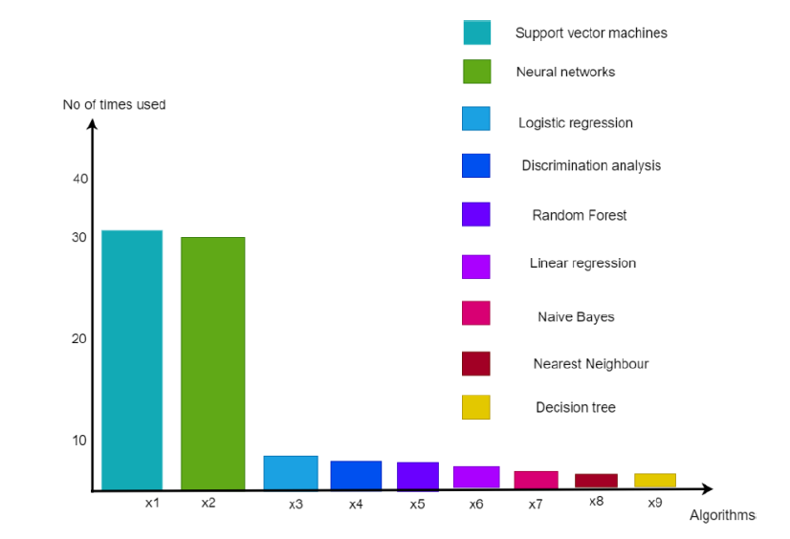

## 

## Figure 3.1: Feasibility study for Home Care Service

## Idea: We have planned to design the Smart Health Prediction System using PHP language and MySQL.

**3.1 ECONOMIC FEASIBILITY**

This study is carried out to check the economic impact will have on the system will have on the organization. The amount of fund that the company can pour into the research and development of the system is limited. The expenditures must be justified. Thus the developed system as well within the budget and this was achieved because most of the technologies used are freely available. Only the customized products have to be purchased.

1. All Hardware and software cost has to be borne by the organization

2. Overall we have estimate that the benefit the organization is going to receive from the proposed system will surely overcome initial cost and the later on running cost for system.

**3.2 TECHNICAL FEASIBILITY**

This study is carried out to check the technical feasibility, that is the technical requirements of the system. Any system developed must not have a high demand on the available technical resources. This will lead to high demands being placed on the client. The developed system must have a modest requirement, as only minimal or null changes for the implementing this system.

**3.3 OPERATIONAL FEASIBILITY**

## The aspect of study is to check the level of acceptance of the system by the user. This includes the process of training the user to use the system efficiently. The user must not feel threatened by the system, instead must accept it as a necessity. The level of acceptance by the users solely depends on the methods that are employed to educate the user about the system and to make him familiar with it. His level of confidence must be raised so that he is also able to make some constructive criticism, which is welcomed, as he is the final user of the system.

## CHAPTER 4 PROJECT METHODOLOGY

A diagram is the graphical presentation of a set of elements, most often rendered as a connected graph of vertices and arcs you draw diagram to visualize a system from different perspective, so a diagram is a projection into a system. For all but most trivial systems, a diagram represents an elided view of the elements that make up a system. In theory, a diagram may contain any combination of things and relationships.

## Block Diagram for HCS

Admin

Admin has Authentication Customer and Worker information

Worker Get Notification Registered Customer Home Care

Customer

Worker

Service System

View customer Search Worker

**Figure: 4.1 Block Diagram of HCS**

In practice, however, a small number of common combinations arise, which are consistent with the five most useful views that comprise the architecture of a software-intensive system. the Project enabled VTT to gain new understanding and methodological competence in accessibility, user needs, and integrated service-driven modernisation of buildings. VTT is focusing on R&D and innovation services within the framework of sustainable development of technologies. We are expecting new types of innovations to emerge in future: combinations of technologies for user-inspired and service-driven social innovations. In the short run, results from the Project will enhance and support our dialogue with authorities and companies

## 4.2 Modules Description

## Login

* In customer portal, the customer can login by their username and password.
* In worker portal, the worker can login by their username and password.

## Worker module

* This module includes the worker registering in our portal by submitting details like name, contact number, Email ID, address and password.
* After submitting their details, they need to add their work experience.
* The worker can check and change the status of customer service request.
* The workers can analyze the user message in their portal.

## Customer module

* In this module, Customers can register themselves by logging in with their username and password.
* When customers want to schedule a service, they can do it by logging in to their account.
* The portal is specialized with an interactive user interface which provides attractive way of booking a service, where customers are requested to provide the details about the services required.
* When done, the request is submitted.
* **Admin module**
* In this module, Admin need to login by their password in admin login portal.
* Admin can view the details of customers and workers which the customers and workers given in registration step.
* Admin can analyze the feedback of customer and make an action to worker.

## CHAPTER 5

**RESULT AND DISCUSSION**

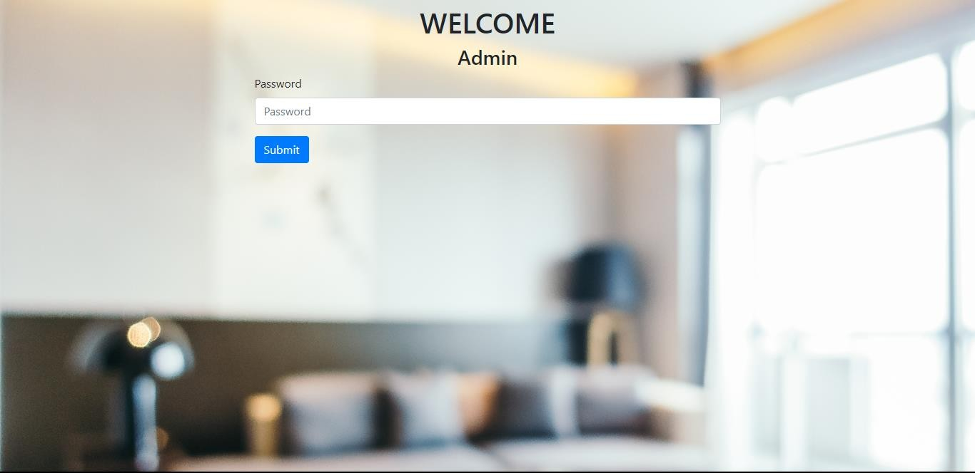

**Figure 5.1 Screenshot of Admin Sign-in Page**

This figure deals with the admin sign-in the process according to the program implemented in PHP.

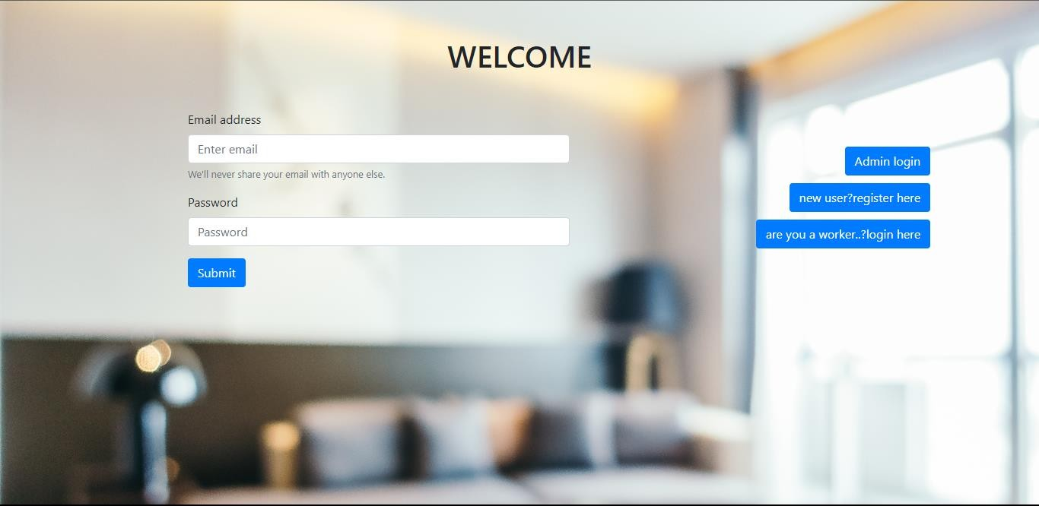

**Figure 5.2 Screenshot of User Sign-in Page**

This figure deals with the User sign-in the process according to the program implemented in PHP.

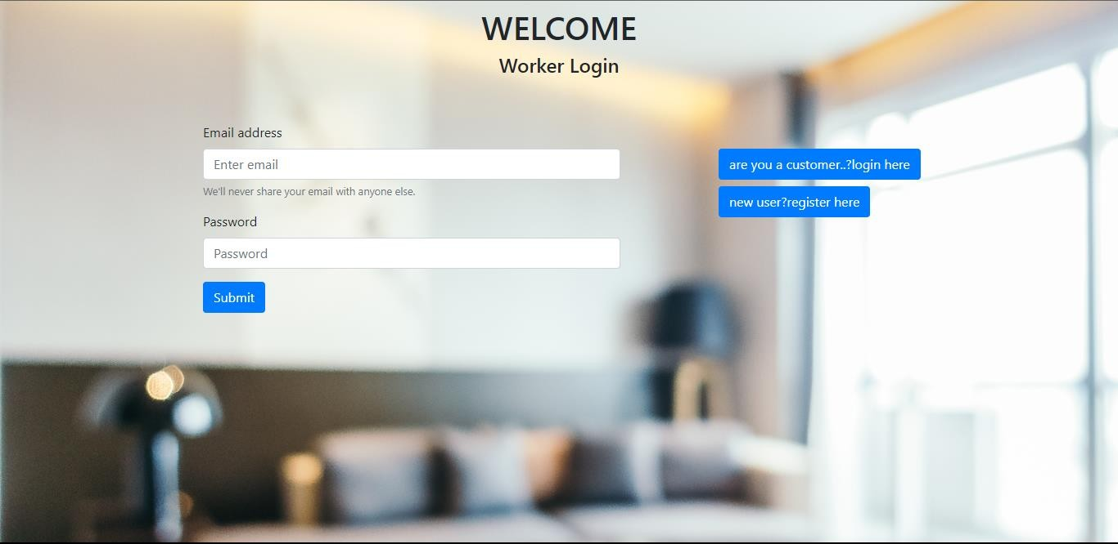**Figure 5.3 Screenshot of Worker Sign-in Page**

This figure deals with the Worker sign-in the process according to the program implemented in PHP

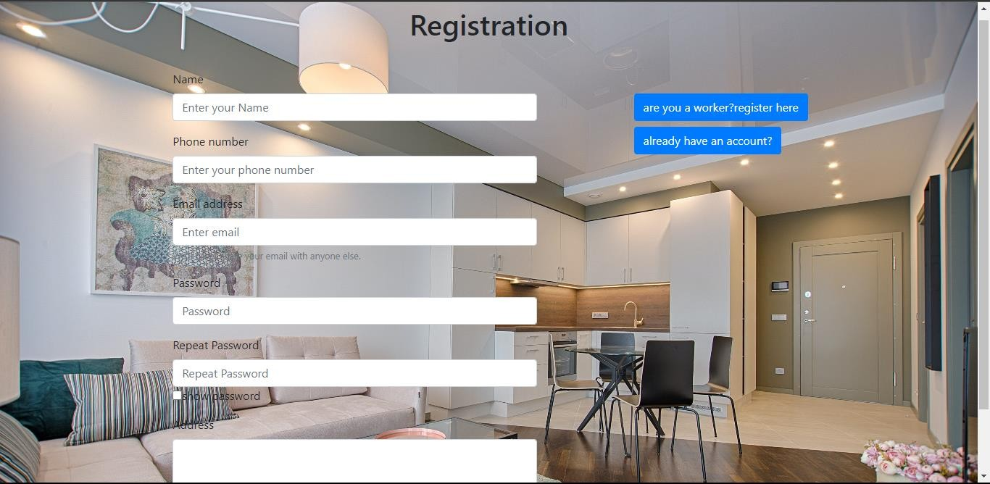

**Figure 5.4 Screenshot of User Registration Page**

This figure deals with the adding a new account for the new user process according to the program implemented in PHP.

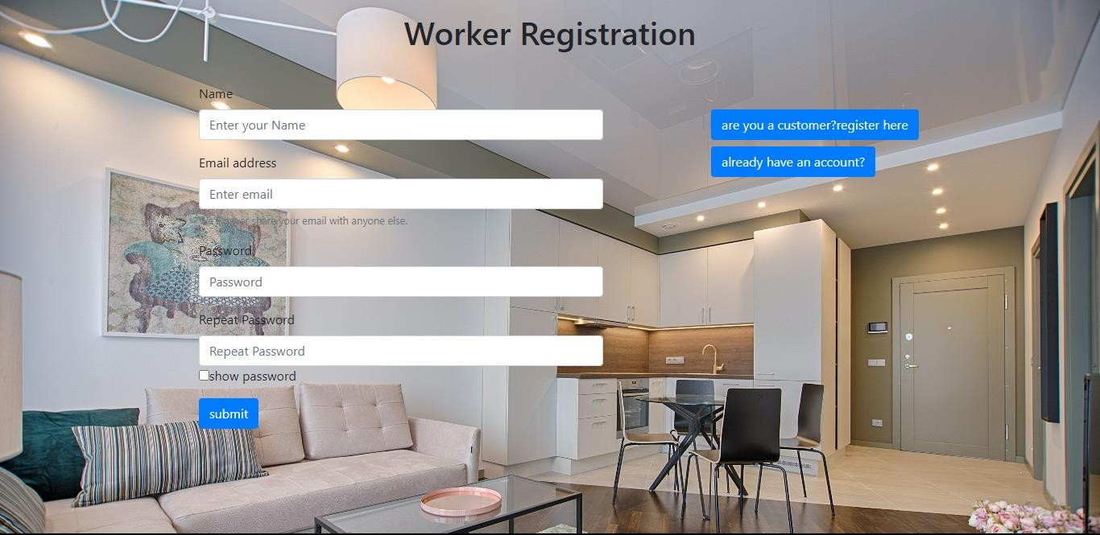

**Figure 5.5 Screenshot of Worker Registration Page**

This figure deals with the adding a new account for the new worker process according to the program implemented in PHP.

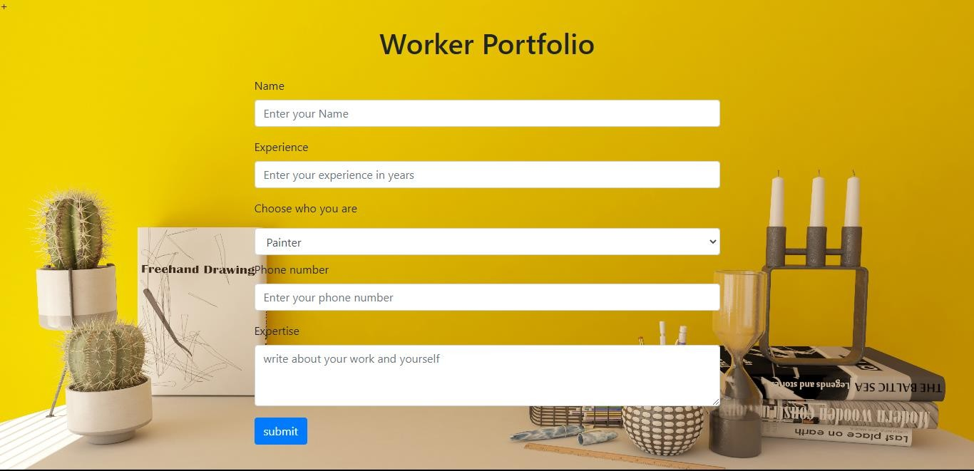

**Figure 5.6 Screenshot of Worker Profile Page**

This figure deals with the adding workers experience and expertise.

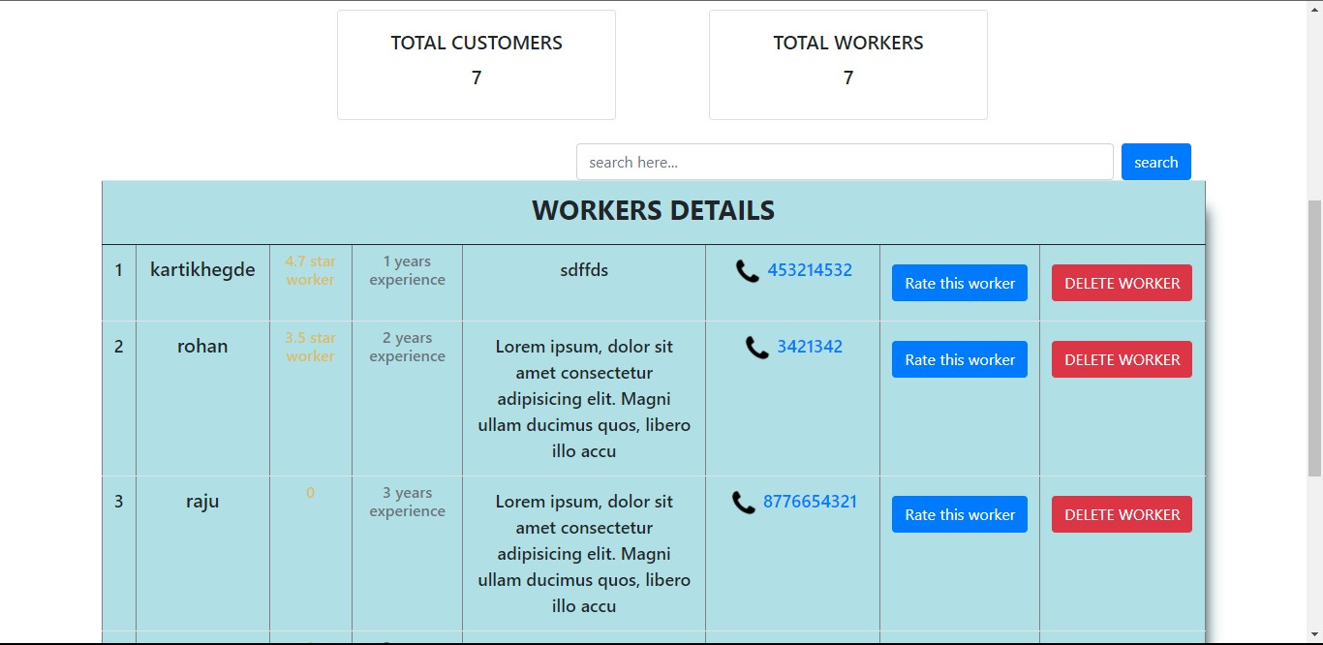

**Figure 5.7 Screenshot of Worker and User Details Page**

This figure deals with the admin page that contains the details of worker and user details, action can be performed.

## CHAPTER 6 CONCLUSION

The site is created which offer internet based home assistance booking. It will give a decent easy to use interface for booking the administrations. To reduce burden in finding in-house solutions for the services, the proposed system provides several services by providing service specialists at your doorstep in one click. The customers needs will be satisfied in efficient manner. Our system increase the work opportunity among the people who are really talented and with good payments and rewards.

The Home Care Services project is a vital initiative that will meet the growing demand for home based care services. By taking a person-cantered approach and prioritizing caregiver training and support, the project will provide high-quality, compassionate, and personalized care services to individuals in their own homes. The project revealed that there is a significant demand for household services, including cleaning, maintenance, and repairs. This is supported by the high number of service requests received during the project, indicating that homeowners and residents are actively seeking professional assistance for their homecare needs.

**FUTURE WORKS**

The online household services application provides some of the home services which are most frequently used. This system accommodates the changing needs of the end user. Further this application can be prolonged by merely adding up the required services and additional payment systems. For example, the current system provides the following services such as home painting, home cleaning, packers and movers, plumber repair and service further the system can be extended as per the requirements of the user. The system can have prolonged by adding the services such as mobile and computer repair, laundry services, catering services and many more. The discussion payment methods our system has, for example currently system has online payment by only MasterCard users further it can be extended by adding the payment service.

## REFERENCE:

* + 1. Shahrzad Shahriari, Mohammadreza Shahriari, Saeid gheiji. “ECommerce And It Impactson Global Trend And Market”. International Journal of Research – Granthaalayah.Vol.3 (Iss.4): April, 2015.
    2. L.RichardYe, Yue Jeff Zhang, Dat-DaoNguyen, James Chiu,“Fee-based online services: Exploring consumers’ willingness to pay ”. Journal of International Technologyand Information Management.
    3. Bo Zhang, Ruihan Yong, Meizi Li, Jianguo Pan, Jifeng Huanglaa, “ A Hybrid Trust Evaluation Framework for Ecommerce in Online Social Network: ”. 2169-3536 (c) 2016 IEEE. Translations and content mining are permitted for academic research.

**APPENDIX**

**INDEX:**

<!DOCTYPE html>

<html lang="en" dir="ltr">

<head>

<meta charset="utf-8">

<title>Home</title>

<link rel="stylesheet" href="https://cdn.jsdelivr.net/npm/bootstrap@4.0.0/dist/css/bootstrap.min.css" integrity="sha384-Gn5384xqQ1aoWXA+058RXPxPg6fy4IWvTNh0E263XmFcJlSAwiGgFAW/dAiS6JXm" crossorigin="anonymous">

<script src="https://code.jquery.com/jquery-3.2.1.slim.min.js" integrity="sha384-KJ3o2DKtIkvYIK3UENzmM7KCkRr/rE9/Qpg6aAZGJwFDMVNA/GpGFF93hXpG5KkN" crossorigin="anonymous"></script>

<script src="https://cdn.jsdelivr.net/npm/popper.js@1.12.9/dist/umd/popper.min.js" integrity="sha384-ApNbgh9B+Y1QKtv3Rn7W3mgPxhU9K/ScQsAP7hUibX39j7fakFPskvXusvfa0b4Q" crossorigin="anonymous"></script>

<script src="https://cdn.jsdelivr.net/npm/bootstrap@4.0.0/dist/js/bootstrap.min.js" integrity="sha384-JZR6Spejh4U02d8jOt6vLEHfe/JQGiRRSQQxSfFWpi1MquVdAyjUar5+76PVCmYl" crossorigin="anonymous"></script>

<link rel="stylesheet" href="styl.css">

<link rel="stylesheet" href="https://cdnjs.cloudflare.com/ajax/libs/font-awesome/5.15.3/css/all.min.css"/>

</head>

<body>

<?php

require('./session.php');

?>

<nav>

<label class="logo">Home care Services</label>

<ul>

<li><a href="index.php">Home</a></li>

<li><a href="about.php">about</a></li>

<li>

<a href="#">Services

<i class="fas fa-caret-down"></i>

</a>

<ul>

<li><a href="Painters.php">Painters</a></li>

<li><a href="Electrician.php">Electrician</a></li>

<li><a href="Cook.php">Cook</a></li>

<li><a href="Homecleaners.php">Homecleaners</a></li>

</ul>

</li>

</li>

<li><a href='<?php

if($_SESSION['user']=='admin'){

echo "admin.php";}

else if(isset($_SESSION['worker']))

{echo "services.php"; }

else{

echo "cust_services.php";} ?>'> status</a></li>

<li><a href="logout.php">Logout</a></li>

</ul>

</nav>

<section></section>

</body>

</html>

**LOGIN:**

<!DOCTYPE html>

<html lang="en">

<head>

<meta charset="UTF-8">

<meta http-equiv="X-UA-Compatible" content="IE=edge">

<meta name="viewport" content="width=device-width, initial-scale=1.0">

<link rel="stylesheet" href="https://cdn.jsdelivr.net/npm/bootstrap@4.0.0/dist/css/bootstrap.min.css" integrity="sha384-Gn5384xqQ1aoWXA+058RXPxPg6fy4IWvTNh0E263XmFcJlSAwiGgFAW/dAiS6JXm" crossorigin="anonymous">

<script src="https://code.jquery.com/jquery-3.2.1.slim.min.js" integrity="sha384-KJ3o2DKtIkvYIK3UENzmM7KCkRr/rE9/Qpg6aAZGJwFDMVNA/GpGFF93hXpG5KkN" crossorigin="anonymous"></script>

<script src="https://cdn.jsdelivr.net/npm/popper.js@1.12.9/dist/umd/popper.min.js" integrity="sha384-ApNbgh9B+Y1QKtv3Rn7W3mgPxhU9K/ScQsAP7hUibX39j7fakFPskvXusvfa0b4Q" crossorigin="anonymous"></script>

<script src="https://cdn.jsdelivr.net/npm/bootstrap@4.0.0/dist/js/bootstrap.min.js" integrity="sha384-JZR6Spejh4U02d8jOt6vLEHfe/JQGiRRSQQxSfFWpi1MquVdAyjUar5+76PVCmYl" crossorigin="anonymous"></script>

<title>Login</title>

<style>

body{

background-image: url('2.jpg');

background-repeat: no-repeat;

background-size: cover;}

.grid{

display:grid;

grid-template-columns: 2fr 1fr; }

</style>

</head>

<body><div style="margin-top:20px ;">

<h1 align='center' class='my-5'>HOME CARE SERVICE</h1> </div>

<div class="container grid" style="margin-top:120px ;">

<div class="container">

<form class='container w-75 ' action='' method='post'>

<div class="form-group">

<label for="exampleInputEmail1">Email address</label>

<input type="email" class="form-control" name='email' id="exampleInputEmail1" aria-describedby="emailHelp" placeholder="Enter email">

<small id="emailHelp" class="form-text text-muted">We'll never share your email with anyone else.</small>

</div>

<div class="form-group">

<label for="exampleInputPassword1">Password</label>

<input type="password" class="form-control" name='pass' maxlength='15' minlength='8' id="exampleInputPassword1" placeholder="Password">

</div>

<button type="submit" name='submit' class="btn btn-primary">Submit</button><br>

</form></div>

<div class="container py-5" style='float:right'>

<button class='btn btn-primary' style='float:right'><a style='color:white' href="adminlogin.php">Admin login</a></button> <br> <br>

<button class='btn btn-primary' style='float:right'> <a style='color:white' href="register.php">new user?register here</a></button> <br> <br>

<button class='btn btn-primary' style='float:right'><a style='color:white' href="worker_login.php">are you a worker..?login here</a></button> <br> <br>

</div>

</div>

<!DOCTYPE html>

<html lang="en">

<head>

<meta charset="UTF-8">

<meta name="viewport" content="width=device-width, initial-scale=1.0">

<title>Login</title>

<link rel="stylesheet" href="style1.css">

</head>

<body>

<input type="checkbox" id="show">

<label for="show" class="show-btn-worker">Worker LOG IN > </label>

<label for="show" class="show-btn"> LOG IN > </label>

<div class="container">

<label for="show" class="close-btn" title="close"></label>

<h1>Welcome</h1>

<form action="logconn.php" method="post">

<label for="username"><b>Email,User name or Phone</b></label>

<input type="text" placeholder="Enter Email,User or Phone" name="username" required>

<label for="psw"><b>Password</b></label>

<input type="password" placeholder="Enter your password" name="psw" id="psw" pattern="(?=.*\d)(?=.*[a-z])(?=.*[A-Z]).{8,}" title="Must contain at least one number and one uppercase and lowercase letter, and at least 8 or more characters" required>

<a href="#">Forgot Password?</a>

<button>Submit</button>

</form></div>

</body>

</html>

<?php

if(isset($_POST['submit']) && $_SERVER['REQUEST_METHOD'] == 'POST')

{

//form variables

$uname=$_POST['email'];

$pswd=$_POST['password'];

//db connection

require('../db_connect/database.php');

if($conn->connect_error)

{

die("Connection failed:" .$conn->connect_error);

}

else

{

$sql1="SELECT `psw`,`regid` FROM `registration` where `email`='$uname'";

$result = $conn->query($sql1);

if($result->num_rows>0)//when db records are found store in associative array...

{

// output data of each row

while($row = $result->fetch_assoc())

{

$pass=$row['psw'];

$worker_id=$row['regid'];

}

if($pass==md5($pswd)){

session_start();

$_SESSION['user'] = $pass;

$_SESSION['worker']= $worker_id;

echo"<script language='javascript'>

window.location.href ='services.php';

</script>";

}

else{

echo "<script language='javascript'>

alert('wrong password');

location.href='login.php';

</script>";

}

}else{

echo "<script language='javascript'>

alert('user do not exist');

location.href='login.php';

</script>";} }}?>

**WORKER REGISTRATION:**

<!DOCTYPE html>

<html lang="en">

<head>

<meta charset="UTF-8">

<meta http-equiv="X-UA-Compatible" content="IE=edge">

<meta name="viewport" content="width=device-width, initial-scale=1.0">

<link rel="stylesheet" href="https://cdn.jsdelivr.net/npm/bootstrap@4.0.0/dist/css/bootstrap.min.css" integrity="sha384-Gn5384xqQ1aoWXA+058RXPxPg6fy4IWvTNh0E263XmFcJlSAwiGgFAW/dAiS6JXm" crossorigin="anonymous">

<script src="https://code.jquery.com/jquery-3.2.1.slim.min.js" integrity="sha384-KJ3o2DKtIkvYIK3UENzmM7KCkRr/rE9/Qpg6aAZGJwFDMVNA/GpGFF93hXpG5KkN" crossorigin="anonymous"></script>

<script src="https://cdn.jsdelivr.net/npm/popper.js@1.12.9/dist/umd/popper.min.js" integrity="sha384-ApNbgh9B+Y1QKtv3Rn7W3mgPxhU9K/ScQsAP7hUibX39j7fakFPskvXusvfa0b4Q" crossorigin="anonymous"></script>

<script src="https://cdn.jsdelivr.net/npm/bootstrap@4.0.0/dist/js/bootstrap.min.js" integrity="sha384-JZR6Spejh4U02d8jOt6vLEHfe/JQGiRRSQQxSfFWpi1MquVdAyjUar5+76PVCmYl" crossorigin="anonymous"></script>

<title>Login</title>

<style>

body{

background-image: url('back2.jpg');

background-repeat: no-repeat;

background-size: cover;

}

.grid{

display:grid;

grid-template-columns: 2fr 1fr;

}

</style>

</head>

<body>

<?php

session_start();

?>

<h1 class='my-3' align='center'>Worker Registration</h1>

<div class="container grid"><div class="container">

<form class='container my-4 w-75' id='myform' action='' method='post'>

<div class="form-group">

<div class="form-group">

<label for="exampleInputPassword1">Name</label>

<input type="text" class="form-control" name='name'required placeholder="Enter your Name">

</div> <label for="exampleInputEmail1">Email address</label>

<input type="email" required class="form-control" name='email' id="exampleInputEmail1" aria-describedby="emailHelp" placeholder="Enter email">

<small id="emailHelp" class="form-text text-muted">We'll never share your email with anyone else.</small>

</div>

<div class="form-group">

<label for="exampleInputPassword1">Password</label>

<input type="password" onkeyup='passwordChanged()' maxlength='15' onblur='removestyle()' required class="form-control" name='password' minlength='8' id='pass' placeholder="Password">

<small id='strength'></small>

<p id='StrengthDisp'></p>

<label for="psw-repeat">Repeat Password</label>

<input type="password" class="form-control" placeholder="Repeat Password" name="psw-repeat" required id="psw-repeat">

<input type="checkbox" onclick='handleshowpass()'/>show password

</div>

<input name='submit' type='submit' onclick='check()' value='submit' class="btn btn-primary"></form></div>

<div class="container"> <br> <br><small class='btn btn-primary my-2'><a style='color:white' href="register.php">are you a customer?register here</a></small><br><small class='btn btn-primary'><a style='color:white' href="worker_login.php">already have an account?</a></small></div></div>

<script>

function check(){

if(document.getElementById('pass').value!==document.getElementById('psw-repeat').value){

alert('passwords do not match')

event.preventDefault()

}

}

</script>

<script language="javascript">

function passwordChanged() {

var strength = document.getElementById('strength');

var strongRegex = new RegExp("^(?=.{11,})(?=.*[A-Z])(?=.*[a-z])(?=.*[0-9])(?=.*\\W).*$", "g");

var mediumRegex = new RegExp("^(?=.{10,})(((?=.*[A-Z])(?=.*[a-z]))|((?=.*[A-Z])(?=.*[0-9]))|((?=.*[a-z])(?=.*[0-9]))).*$", "g");

var enoughRegex = new RegExp("(?=.{8,}).*", "g");

var pwd = document.getElementById("pass");

if (pwd.value.length == 0) {

strength.innerHTML = '';

} else if (false == enoughRegex.test(pwd.value)) {

strength.innerHTML = 'Give atleast 8 Characters';

} else if (strongRegex.test(pwd.value)) {

strength.innerHTML = '<span style="color:green">Strong!</span>';

pwd.style.cssText=" box-shadow: 0 1px 5px 0 green"

} else if (mediumRegex.test(pwd.value)) {

strength.innerHTML = '<span style="color:orange">Medium!A combination of special characters and symbols</span>';

pwd.style.cssText=" box-shadow:0 1px 5px 0 orange"

} else {

strength.innerHTML = '<span style="color:red">Weak! Use combination of uppercase letters, lowercase letters, numbers, and symbols</span>';

pwd.style.cssText=" box-shadow:0 1px 5px 0 red",}}

const removestyle=()=>{

var pwd = document.getElementById("pass");

pwd.style.cssText=" box-shadow:0 0 white"}

function handleshowpass(){

var x = document.getElementById("pass");

var x1=document.getElementById("psw-repeat");

if(x.type==="password"){

x.type="text";

x1.type="text";}

else{

x.type="password";

x1.type="password";}

</script>}

<?php

if(isset($_POST['submit'])){

require('../db_connect/database.php');

$uname=$_POST['name'];

$email=$_POST['email'];

$psw=md5($_POST['password']);

if($conn->connect_error)

die("Connection failed:" .$conn->connect_error);

else{

$sql1="SELECT * FROM `registration` where `email`='$email'";

$result = $conn->query($sql1);

if($result->num_rows>0)//when db records are found store in associative array...{

echo"<script language='javascript'>

alert('user already exists');

location.href='w_register.php';

</script>";

}else{

$sql2 ="INSERT INTO `registration`( `uname`,`email`,`psw`) VALUES ('$uname','$email','$psw')";

if($conn->query($sql2)===TRUE){

$_SESSION['email']=$email;

echo "<script language='javascript'>

location.href='w_details.php';

</script>";

}}}}ob_flush();

?>

</body></html>